Image Classification using Deep Learning
1. Objective
The objective of this project is to build a deep learning model for image classification using a Convolutional Neural Network (CNN). The model is trained to classify images into different categories.

2. Dataset
The dataset used is the CIFAR-10 dataset, which contains:
- 60,000 color images
- 10 different classes (airplane, automobile, bird, cat, deer, dog, frog, horse, ship, truck)
- Image size: 32 × 32 pixels
The dataset is divided into:
- Training set: 50,000 images
- Testing set: 10,000 images

3. Data Preprocessing
The following preprocessing steps were applied:
- Normalized pixel values to range 0–1
- Split dataset into training and testing sets
- No missing values were present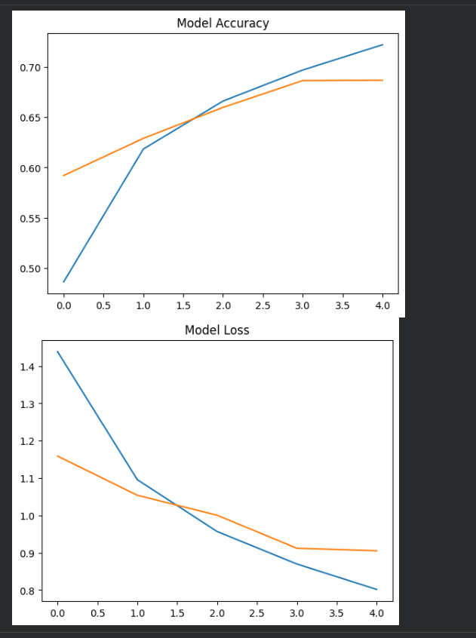

4. Model Architecture
A Convolutional Neural Network (CNN) was used with the following layers:
- Convolutional layers (Conv2D) for feature extraction
- MaxPooling layers for dimensionality reduction
- Flatten layer to convert data into vector form
- Dense (fully connected) layers for classification
- Output layer with Softmax activation
- 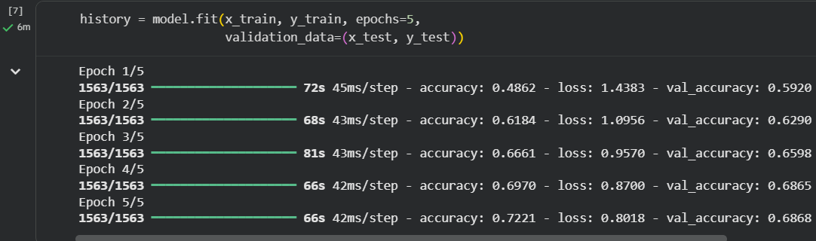

5. Training Process
- Optimizer: Adam
- Loss Function: Sparse Categorical Crossentropy
- Number of Epochs: 5
- Validation data used during training

6. Evaluation Metrics
The model performance was evaluated using:
- Accuracy
- Loss

7. Results
- Validation Accuracy: 0.6868
- Test Accuracy: 0.686800003051757
The model showed consistent learning across epochs, as seen in the validation accuracy graphs.

8. Visualization
The following graphs were plotted:
- Accuracy vs Epochs
- Loss vs Epochs
These graphs help in understanding model performance and detecting overfitting or underfitting.

9. Conclusion
The CNN model successfully classified images from the CIFAR-10 dataset with good accuracy. The results demonstrate that deep learning models are effective for image classification tasks.

10. Future Improvements
- Increase number of epochs for better accuracy
- Use transfer learning (e.g., pretrained models)
- Apply data augmentation techniques
- Tune hyperparameters

11. References
- TensorFlow and Keras documentation
- CIFAR-10 dataset

